Ganesh Nachiappan

JAVA DEVELOPER – SUMMATIVE CAPSTONE PROJECT - Cohort One Project Name: Car Rental Management System

Purpose
This project is being taken up for demonstrating skills acquired during the training. The scope of the project is decided to be as below:

Background of Car Rental system
This section describes the business to which the software solution is built for.
It is a one branch car rental shop. The owner sources cars and introduce to the fleet of Vehicles for rental. Customers come to the counter for on-the-spot rental. The shop opens from 09:00 to 21:00. The fare model is similar to hotel room, and is charged by the day from 14:00 to 12:00 next day. Car collection from 09:00 to 14:00, if available, will be charged as per daily rate pricing. Cars returned late between 12:00 to and 21:00 will be charged extra 25% to 50% of daily rate.
The future of the company. How the business owner envisage the business will expand. Those will affect the future enhancement that may be needed for the system.

Business Requirements
- Design an intuitive UI for the ease of use.
- The facility for the user to login with his credentials as given during the registration.
- The complete user data should only be visible to the administrator (individual user information can be amended by the user)
- All the rights to remove data from the system will only be available with the “admin”. Users can only add records for hire data and see the list of hires.
- However, the Managers can be given a provision of editing /deleting the data across all the modules barring the user information.
- Addition of vehicles into the system can be done only by the admin and not by any other users /managers.
- The list of customers and their past bookings is to be displayed in the reports section.
- An invoice should be generated internally by the system at the end of the trip.
- Maintain the list of vehicles and allow the employees (users) to book a vehicle for customer.
- The vehicles that are currently in the status of the “free” or any such status should be allowed to be booked.
- Following will be details required in the system
  - Vehicle
    - Model
    - Brand
    - Status
    - Hire details
      - Rate plans
      - All the data pertaining to the current and past hires
      - The current hire will not have the end date.
      - Employee who handled the hire (fulfillment agent)
  - Customer
    - Details
      - Name
      - Address
      - City
      - Phone #
      - Email
      - Website
      - Alternate contact details
      - Proof of identity (id captured or an image)
    - Invoice details per customer
    - Invoice status (paid or not)
  - Employee (all employees may not be the users)
    - Name
    - Id
    - Email
    - Job Title
    - Phone #
  - Users management
    - Username (email)
    - Id
    - Password
    - Position (Role)
  - Invoices (Printing the PDF can be optional, record will suffice)
    - Invoice date
    - Payment date
    - Amount
    - Customer detail
    - Hire details (ID)
- Business Operations by Roles:
  - ALL: for all users.
    - Log-in
    - View non-sensitive own Employee details.
    - Change own password.
    - Book Vehicle for Customers
    - Update Customer’s Data
    - Update Booking Return Data
    - Generate PDF for the Booking Id of respective Customer
  - ADMIN: for administrators
    - Maintain system configuration parameters, such as:
      - Car return grace period.
    - Create, modify, suspend Employees. Suspended Employees are barred from log-in.
    - Reset Employee passwords, Unsuspended Employees.
    - Grant/Revoke Roles to Employees.
  - MANAGER :
    - Same privileges as User
    - View/Edit/Delete data in the portal other than User information
    - Update vehicle log [like Maintenance schedule
    - View/Edit existing vehicles’ information
    - View/Edit hiring rates for vehicles.
  - USER: for front desk who serve customers
    - Create, Modify Customers. Suspend Customers.
    - When Customers are created by USER, they are created with status Suspended. Such Customer has to be Unsuspended by MANAGER before allowed to Vehicles.
    - Search for available Cars base on Customer specifications (filters). Because there is no forward booking, candidate cars are always retrieved from current READY status cars.
    - All Booking starts from now. Customer will provide an expected return date/time. Booking fee is computed for each candidate car.
      - If expected Car return is after 12:00, there is a late return fee of 25% of daily rate.
    - Conclusion and creation of a Booking. Car status is updated to BOOKED upon conclusion of the rental.
    - Return of car. A car can be returned:
      - On-time:
      - Ahead of time: There will be no refund.
      - Late: When a Car is returned after expected date/time, the extra period is charged separately as if it is a new booking from original return date/time.
In all cases, the Booking records will be created/updated and an invoice can be generated in pdf format.
    - Each Booking record must register the date time and staff id who serves the customer, for the renting out as well as the returning, and any late returns.
- Creation and deletion of car Statuses, as well as association of car Status to business operations is an application program maintenance task. Association of car Statuses to specific Car is however a business operation that requires relevant Roles.

Fare Schedule
Booking Fare computation:
- Each car is assigned a base daily rate by MANAGER.
- Phase 1: cars are booked on a daily basis similar to hotels. There is a specific start time of 14:00 and end time of 12:00.
- Same day early dispatch and late return will each attract quarter day to half day rate.
- Penalty factor: For cars returned late, the period from original return date/time to actual return date/time will be subject to separated billing with a percentage based penalty markup.
- The fee module should be developed such that it can be easily changed.

Out of Scope
The following are out of scope:
- The solution is to be deployed in company intra-net, and not meant for internet. It is to be used by company staff.
- User authentication is performed using Spring Framework base on user name and passwords stored in Oracle database. There is no Oauth2 authentication.
- Customers have no direct access to the application. They are served by the company staff. Customer cannot make booking on their own.
- This is not a Human Resources system. It does not handle staff attendance, performance appraisal, nor payroll.
- This is not an accounts receivable system. It does not handle invoicing nor payments.

Technology
Following are applied to develop this project:
- Spring Boot
- Spring Security
- Spring MVC
  - Thymeleaf
  - Bootstrap 4
  - CSS
  - HTML5
  - JavaScript
- Oracle SQL(12c)

Future Enhancement
While building the solution, developer should keep these future enhancements in view, to avoid designs that may hinder the introduction of the following enhancements.
- Booking extension: a customer can call in to extend the current Booking before expiry. Early extensions are charged at normal rate.
- Late extension: a customer can call in to extend the current Booking after expiry. In that case, the period from original expiry to current time will be charged at LATE penalty rate. The period from current time to new expiry will be charged normal rate.
- Change to more responsive and faire fee schedules.
- Allow ADMIN to maintain association of Business Operations to Roles, so that tasks can be assigned to different Roles instead of as defined in original user requirements.
- Creation of new branches, cars can be rented and returned at different branches.
- Customer self-service for registration and forward booking.

ER Diagram

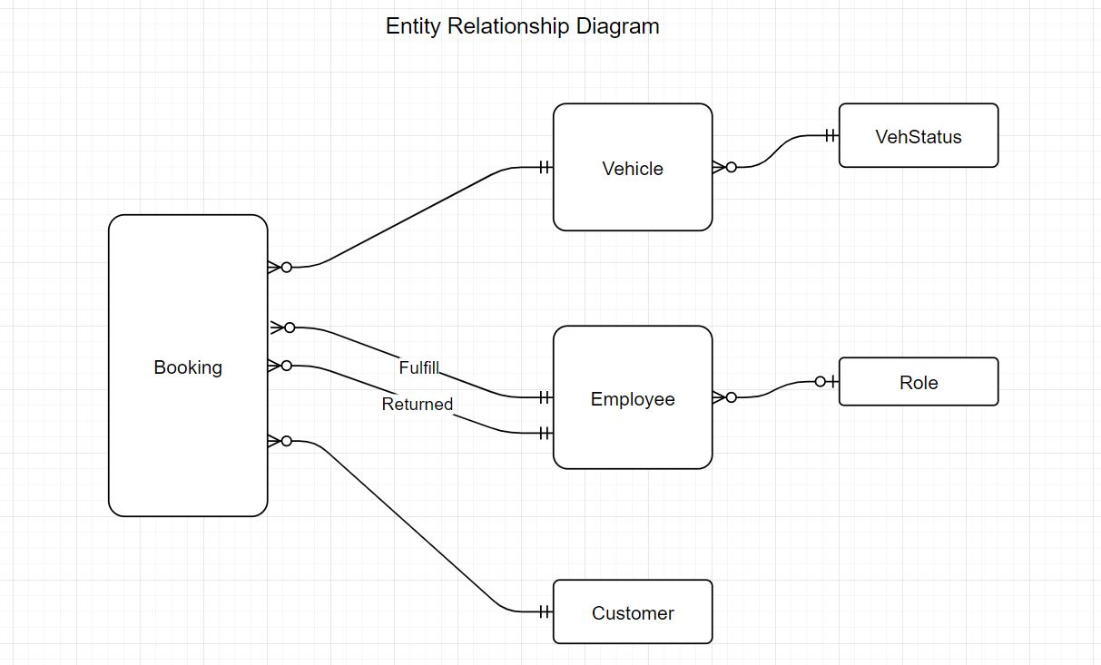

Flow Charts for various Entities
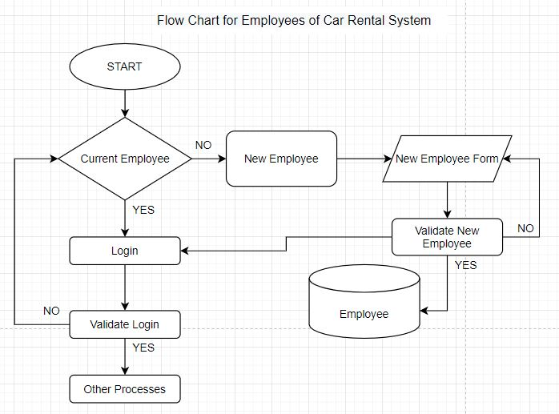

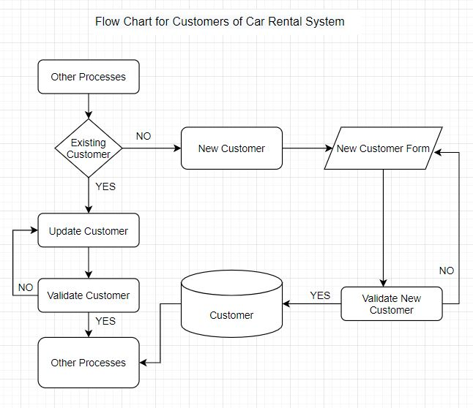

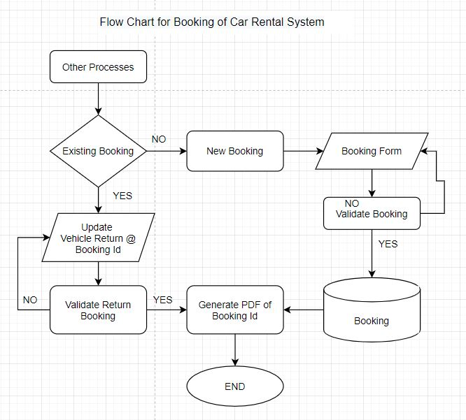

Wireframes
Home Page:
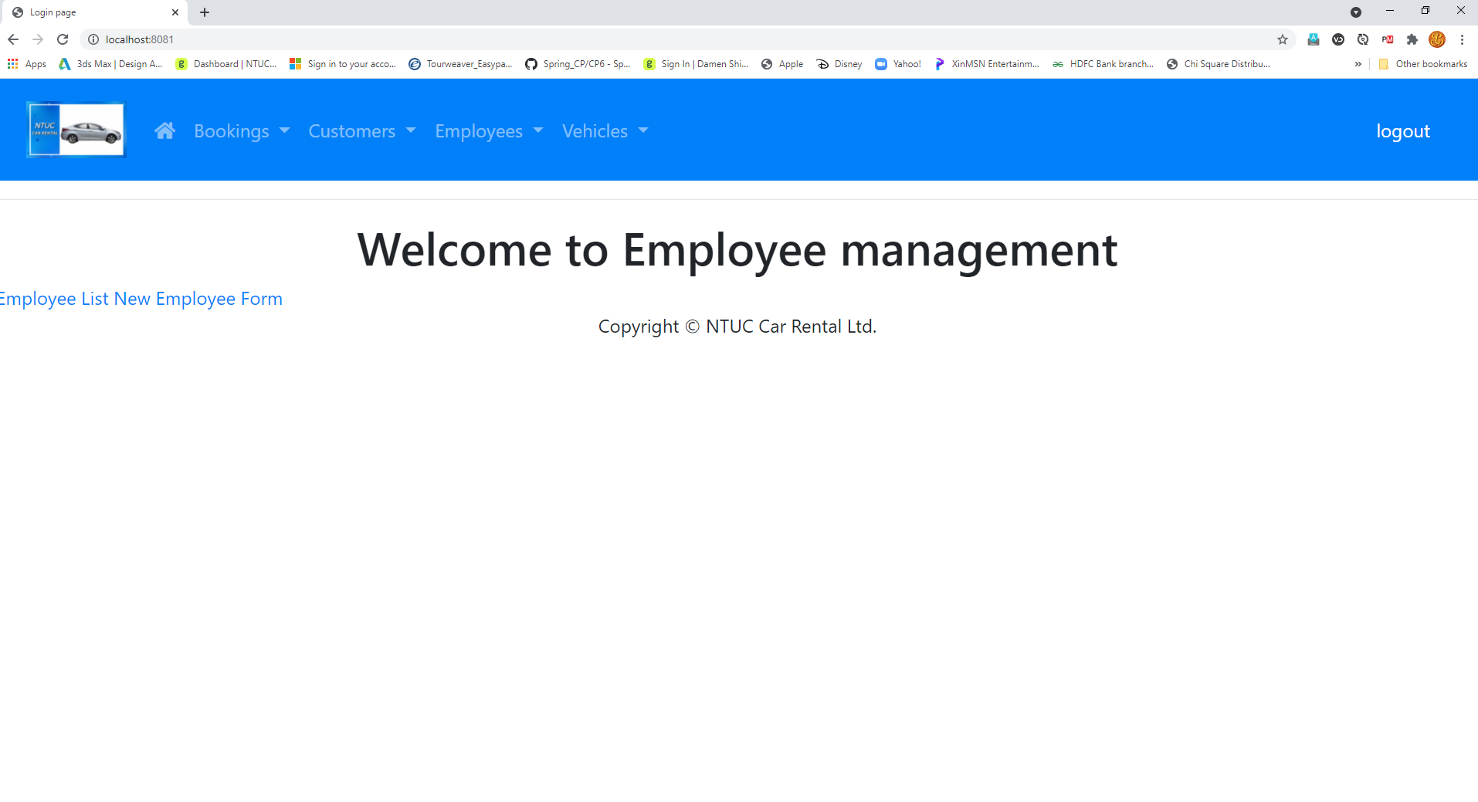

View Employees :

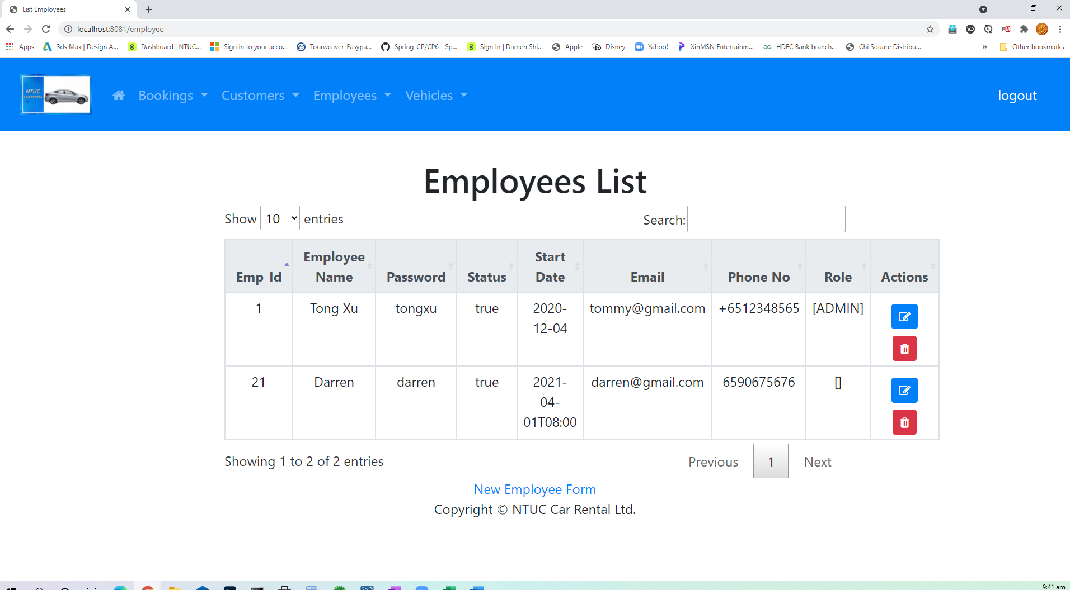

Add New Employee :

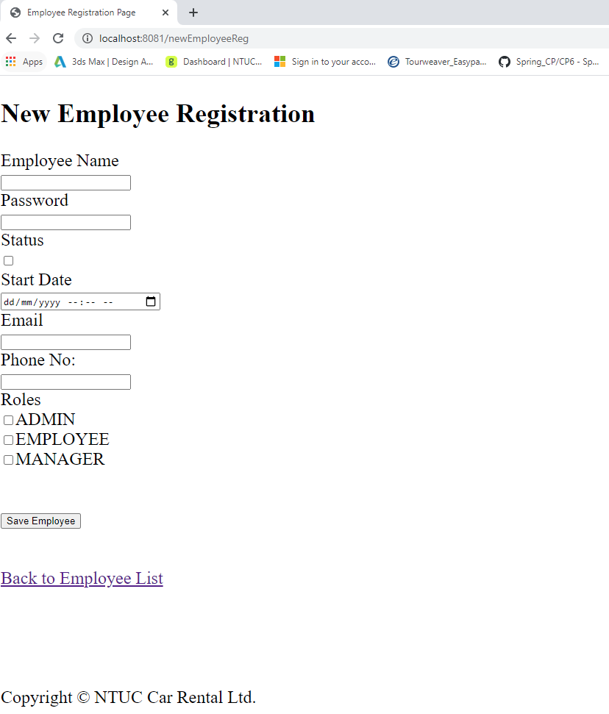

Update Employee Record :

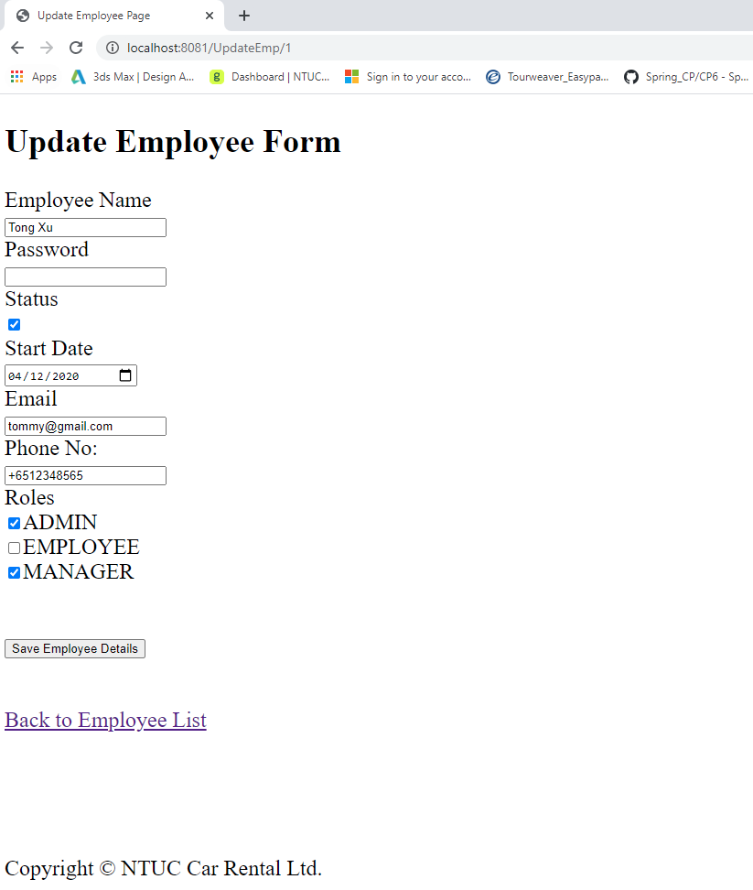

Delete Employee Record :

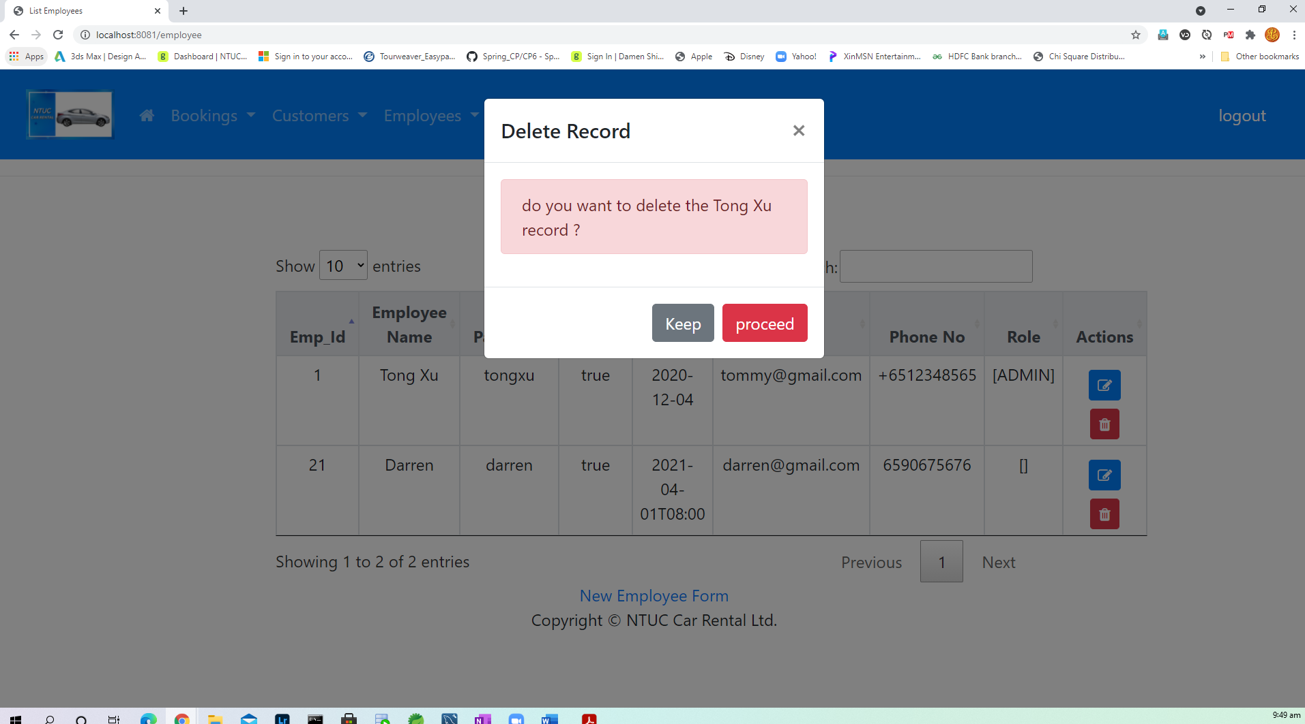

View Vehicles :
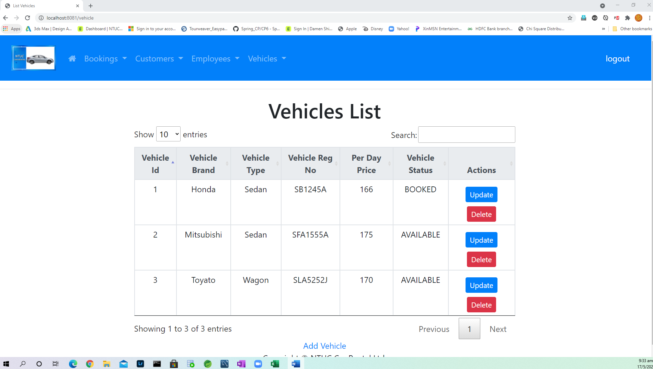

Add New Vehicle :

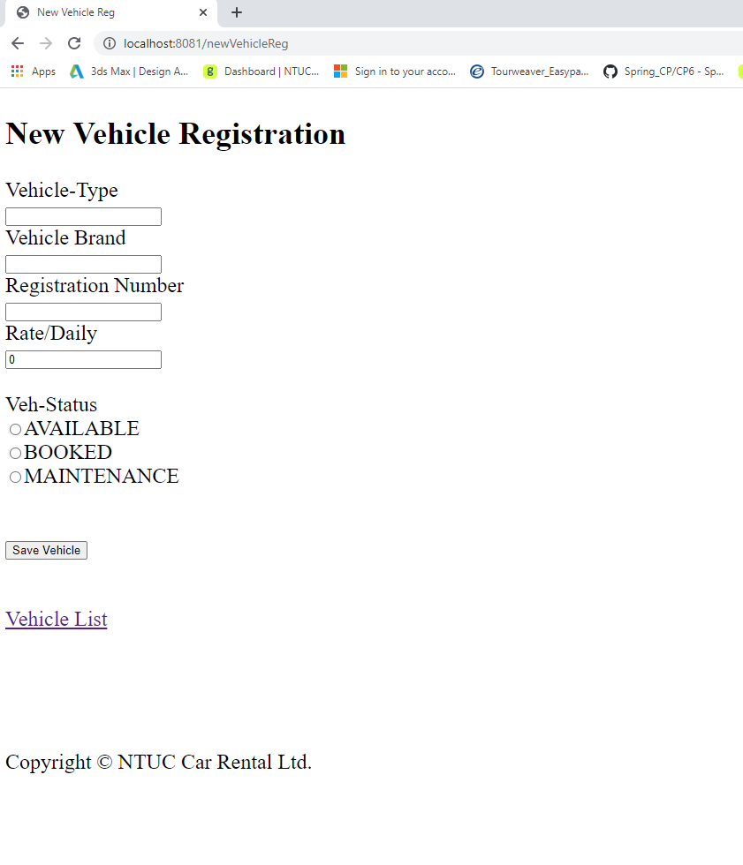

Update Vehicle Details :

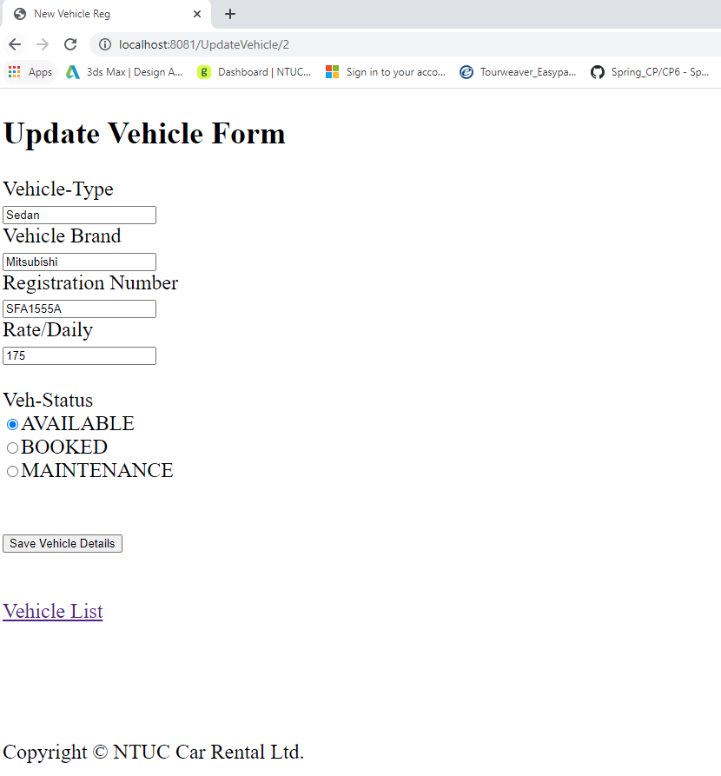

Delete Vehicle Record :

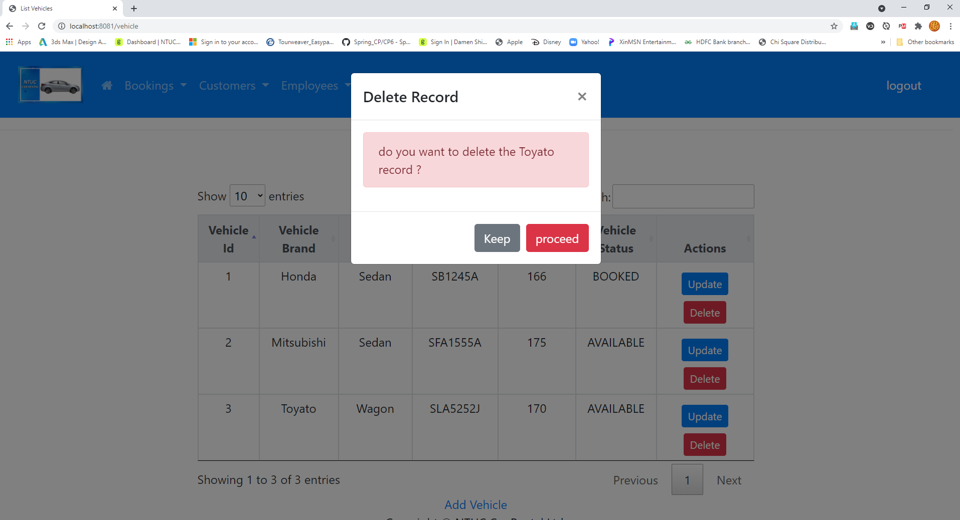

View Bookings :

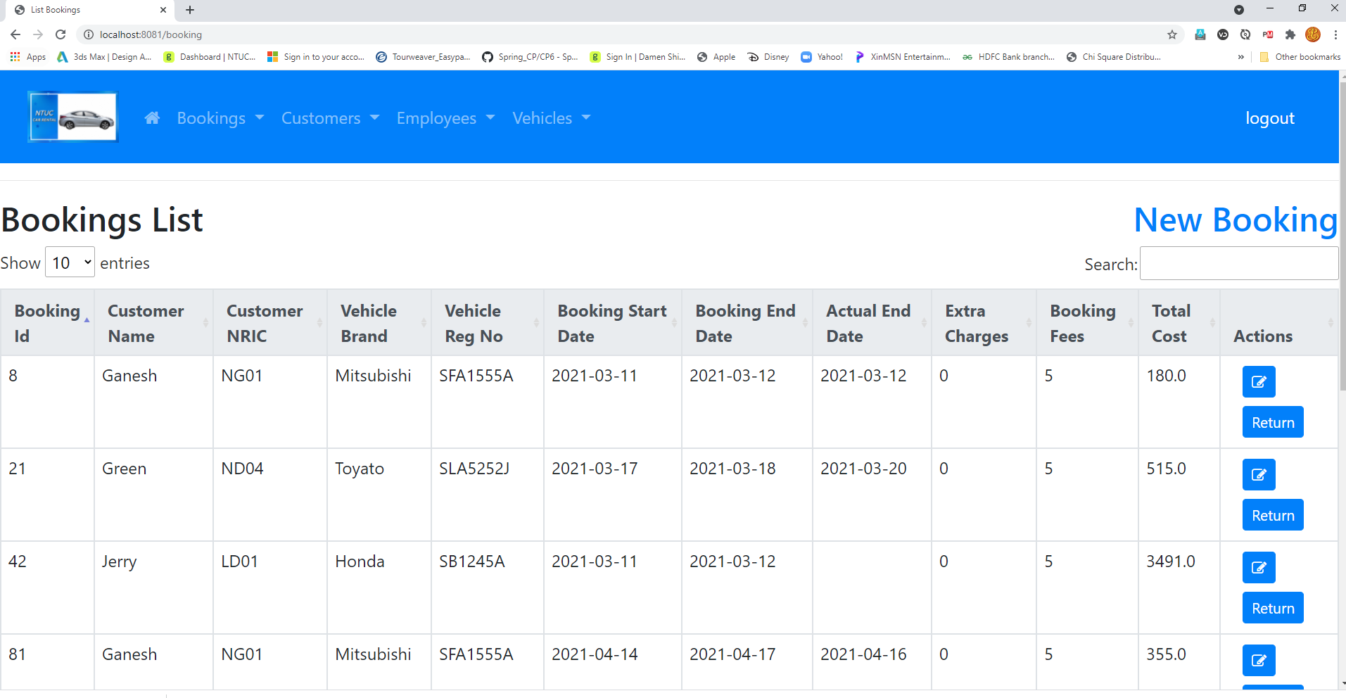

New Booking :

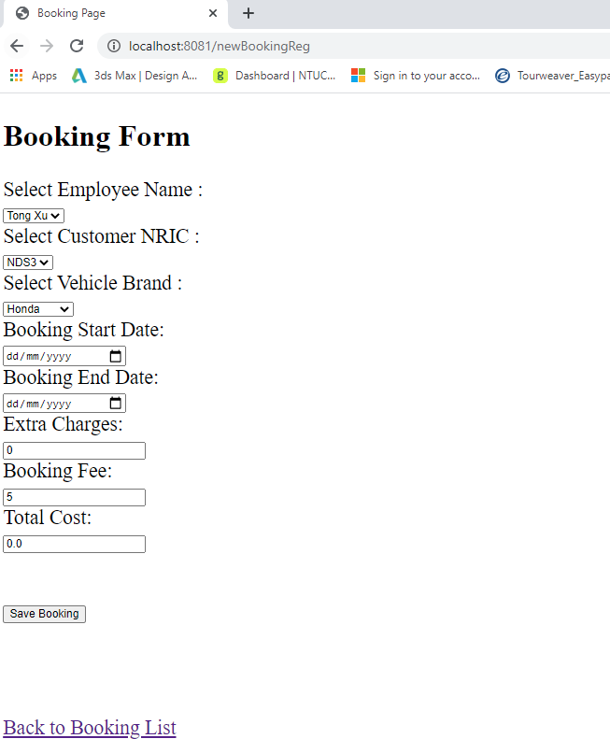

Update Booking is same as New Booking, where can edit and save the details of booking list.
Return Booking :

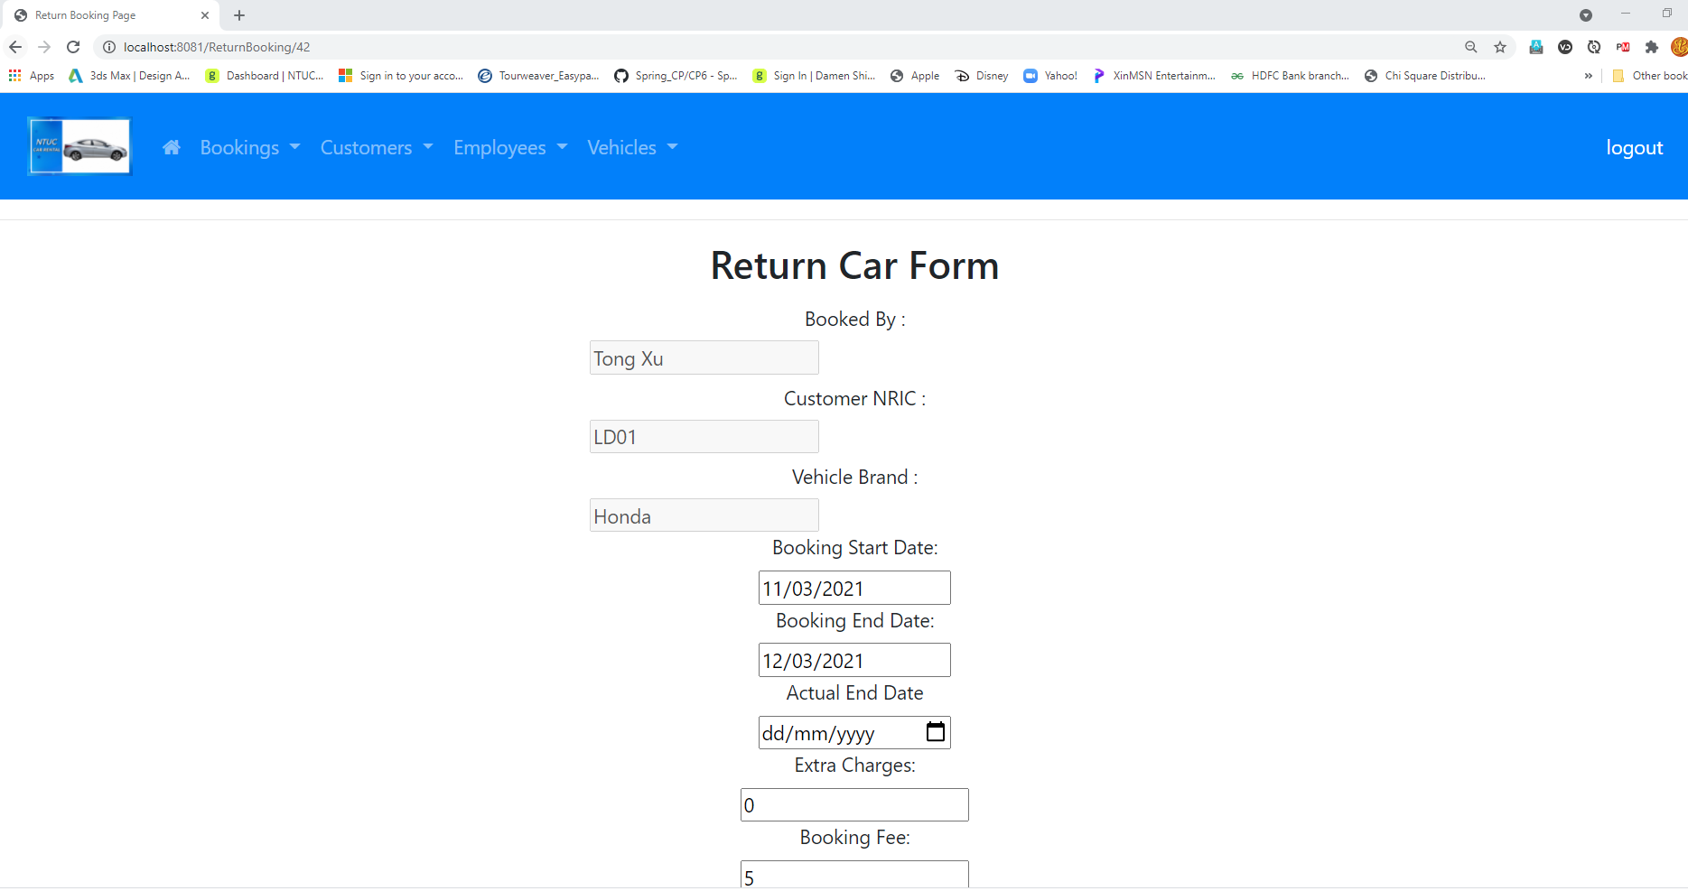

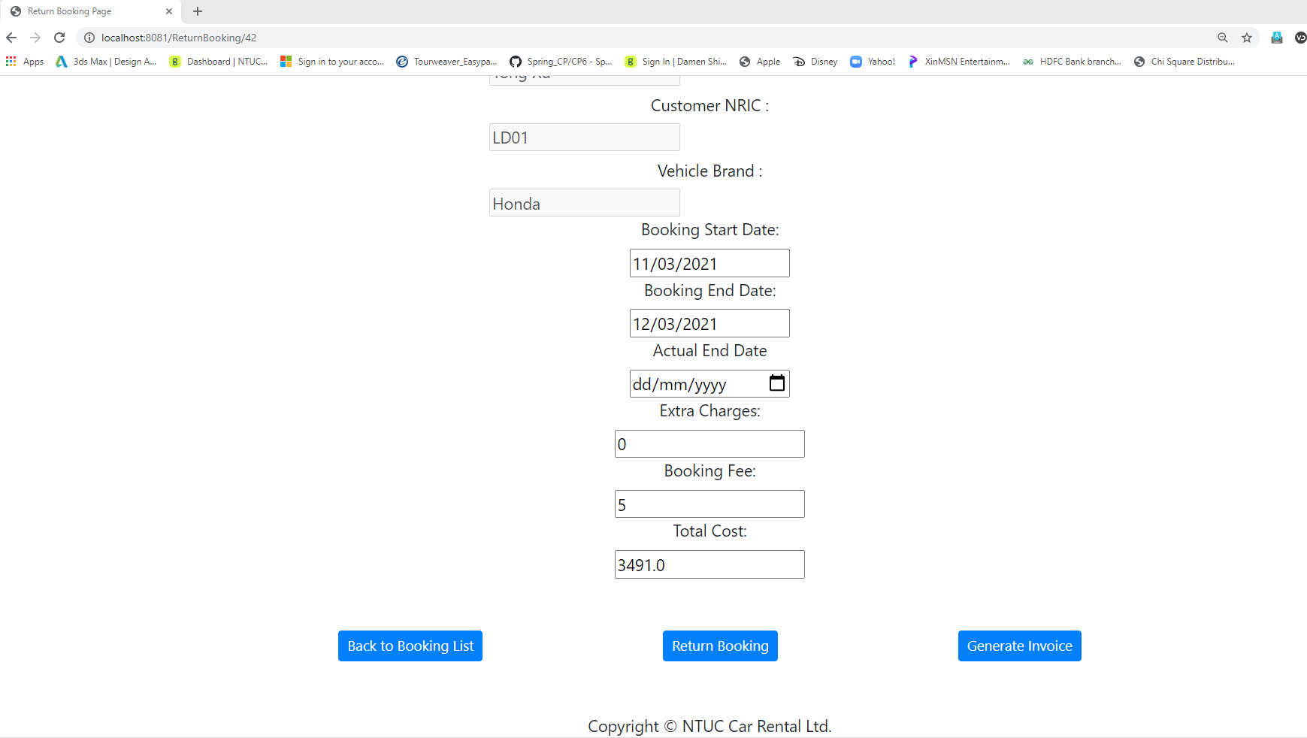

Generated Invoice in pdf (Example):
